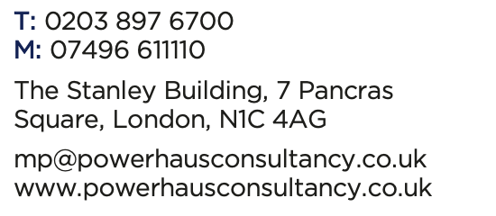

Fossetts Thames Plaza
Land at Eastern Avenue and Fossetts Way Southend-on-Sea
Public Consultation 22nd March 2024

Thank you for taking the time to look at our exhibition.

We hope that you now have a better idea about our proposals. Please take this opportunity to talk with the members of the project team, who will be happy to discuss any aspect of the proposals.

The aim of the exhibition is to allow us to find out your views on the proposals. We would be grateful if you could spare a few minutes to complete this questionnaire with any comments you may have.

Your responses will remain anonymous at all times and allow a range of views to be expressed. All comments on any aspect of the proposals are welcome.

About You (Please tick those that apply):

- Local Business

- Local resident

- Other – Please state……………………………

Your Address details (if you want to be kept informed)
Postcode:……………….

Email address:………….

Address line 1: ………………………….

Address line 2:………………………….

Town/City: ……………………………..

- Do you support the plans to meet the housing needs of the City at Fossetts?

Yes I fully support the plans
Yes, I generally support the plans but have some concerns (please set out your concerns below)
No, I don’t support the plans (please say why below)
I don’t know/ don’t mind

Comments:
__________________________________________________________________________________________________________________________________________________________________________________________________________________

- Is there anything you particularly like about our plans? For example, the architectural design.
________________________________________________________________________________________________________________________________________________________________________________________________________________________________________________________________________________________

- Please set out below any concerns you have with the proposals.
____________________________________________________________________________________________________________________________________________________________________________________________________________________________________________________________________________________________________

- Please use the space below to make any additional comments.
______________________________________________________________________________________________________________________________________________________________________________________________________________________________________________________________________________________________________________________________________________________________

